**2.Web Api using .Net core with Swagger**

Create a .Net core web application with API template. (Use existing application if created). Install Swashbuckle.AspNetCore Nuget package. Post this do the following steps in Startup.cs

Use POSTMAN tool, to point to the local Web API that was created with Employee controller. Test the GET action method using POSTMAN.

Verify the output if the List of employees are listed in the ‘Body’ part of the GET window on POSTMAN tool.

Verify the Status on the right side of the output pane on POSTMAN tool.

Modify the Controller name in the Route attribute of the Employee controller to ‘Emp’ and check its access thru POSTMAN

**CODE**

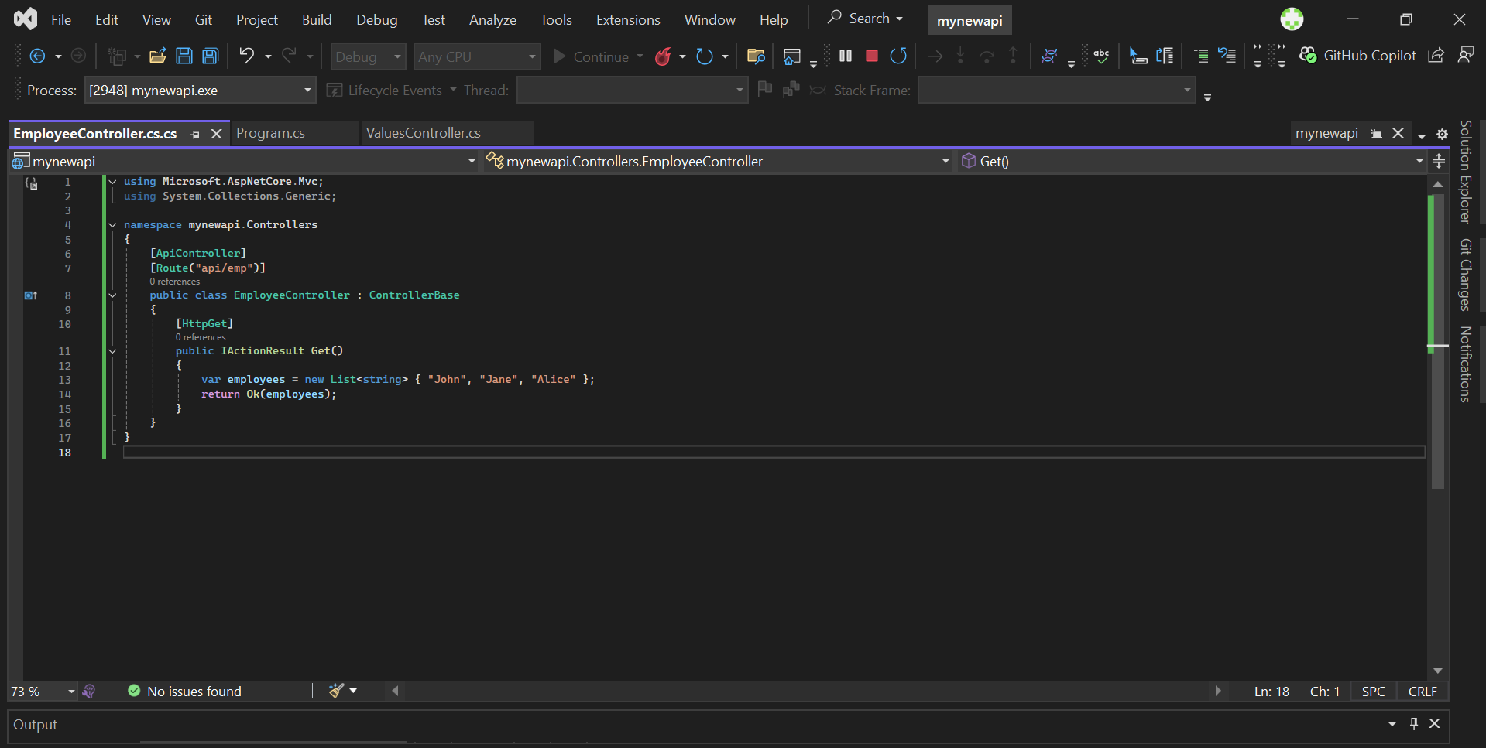

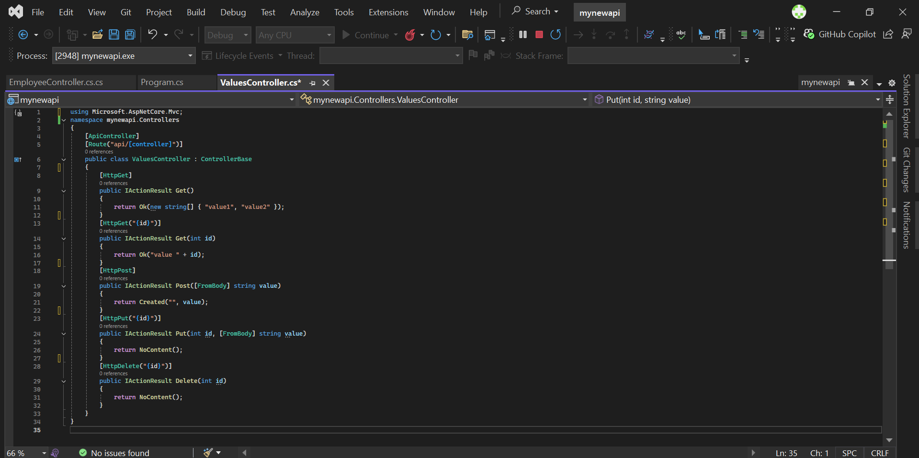

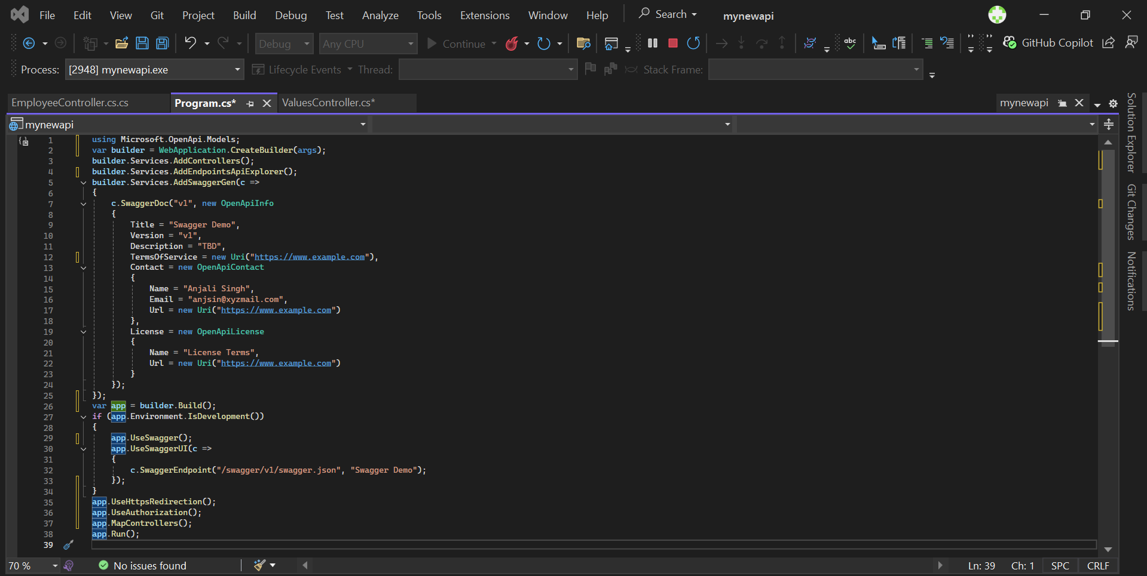

**OUTPUT**

